Software Requirements Specifications

Biometric Attendance Management System and Digital Notice Board

Project Code:
USH404252

Internal Advisor:
Fahad Maqbool

Muhammad Dahir Zaib Bajwa

Project Manager:
Dr. Muhammad Ilyas

Project Team:
Team Leader: M. Haseeb Shahzad (BSEF19M052)
Sulman Arshad (BSEF19M040)
Usama Bajwa (BSEF19M042)

Submission Date:
November 15, 2022

_____________________
Project Manager’s Signature
Document Information

Category | Information
Customer | CS & IT, UOS
Project | Biometric attendance system and digital notice board
Document | Requirement Specifications
Document Version | 1.0
Identifier | PGBH01-2020-RS
Status | Draft
Author(s) | Haseeb  Sulman  Usama
Approver(s) | Dr. Muhammad Ilyas
Issue Date | Sept. 15, 2020
Document Location
Distribution | - Advisor  - PM  - Project Office

Definition of Terms, Acronyms, and Abbreviations

Term | Description
Xampp | Cross-platform, Apache, MySQL, PHP, Perl
PC | Personal Computer
PHP | Hypertext preprocessor
RAM | Random Access memory
CCTV | Closed Circuit Television
LED | Light emitting diode

Table of Contents

1. Introduction 5
1.1 Purpose of Document 5
1.2 Project Overview 5
1.3 Scope 5
2. Overall System Description 5
2.1 User characteristics 5
2.2 Operating environment 5
2.3 System constraints 6
3. External Interface Requirements 6
3.1 Hardware Interfaces 7
3.2 Software Interfaces 7
3.3 Communications Interfaces 7
4. Functional Requirements 8
5. Non-functional Requirements 8
5.1 Performance Requirements 8
5.2 Safety Requirements 8
5.3 Security Requirements 8
5.4 User Documentation 8
6. Assumptions and Dependencies 8
7. System Architecture 9
8. Use Cases 11
8.1 Use Case Diagrams 11
8.2 Use Case Description 12
9. Graphical User Interfaces 17
10. High-Level Design 25
10.1 ER Diagram 25
10.2 Data Dictionary 26
10.2.1 Data 1 26
10.2.2 Data 2 26
10.2.3 Data 3 27
10.2.4 Data 4 27
10.2.5 Data 5 27
10.2.6 Data 6 28
10.2.7 Data 7 28
10.2.8 Data 8 28
10.2.9 Data 9 29
10.2.10 Data 10 29
10.2.11 Data 11 29
10.2.12 Data 12 29
11. Requirements Traceability Matrix 30
12. Risk Analysis 30
13. Cost Estimation Sheet 31
14. References 31

Introduction

  - Purpose of Document
The purpose of the document is to deliver the details of the project, how it will work and how we are going to implement this system. This document also tells about the whole functioning of this system. This document aims to deliver all the aspects of the system like interface, hardware components, software components, cost, etc.

  - Project Overview
This project is about the biometric attendance of professors and showing important notices about the department on digitalized notice board. The major goal of creating this project is to create a system that will generate attendance summaries of professors, monitor time in and out of professors, and show rooms reserved information, and important notices on a digital notice board.
This system aims to generate summaries and record attendance digitally without the use of paperwork which was time-consuming. The benefit of digitalized notice board is to convey important notices fast and efficiently.

  - Scope
The scope of the biometric attendance management system and digital notice board is following
What’s included?
- Monitor time-in and out of professors
- Generate a summary of attendance
- Maintenance of attendance records will be easy
- Room reserved information
- Important notices
- Time Table/ Classes Schedule

What’s excluded?
- Leave management
- No access to staff except admin
- No attendance or leave management for student

Overall System Description
This system is partially self-contained. It will use a simple database for the maintenance of records. It will provide an effective and good hardware and software interface so that the entirely new user will easily interact with this system.

  - User characteristics
There are three types of user which will anticipate this system. The most important user of this system is the admin who is going to manage the whole system. Professor’s class also plays an important role in this system. As this system is built to manage the data of this class because their data is very valuable. The less critical class of this system is the student class which will only interact with a digital noticeboard screen just to get information.

  - Operating environment
The environment to efficiently execute this system is the chrome browser using the Xampp server for the database. The hardware components included in this system are Admin’s PC, Biometric system, and LED screen.

  - System constraints
The constraint for this system includes the:
- Software Constraints
- HTML interpreter server Google Chrome or any Web Browser
- Database Server Apache, MySQL using Xampp
- Development end Angular.js, Java, Bootstrap

- Hardware Constraints
- RAM 256 MB
- Processor Dual-Core CPU 1.30 GHz
- LED Screen Smart LED
- Memory Constraints
- At least 1GB of RAM is required at the server side for effective working
- MySQL also needs at least 114KB of memory
- The clock speed of the server should be almost 1.7 GHz
- Cultural Constraints
- Language English only

- Environmental Constraints
The locations of our hardware components must be in a safe and secure environment as our system includes sensitive fingerprint sensors and a screen of the digital notice board.

- User Constraints
There is one user constraint in our system regarding the digital notice board. Our system includes different attractive and eye-catching colors so that users can read important notices easily.

External Interface Requirements
As this system will be the first attendance management system in CS & IT department so it will be compatible with all external and internal components. And we also generated this system by keeping in view all the algorithms used in the biometric machine.
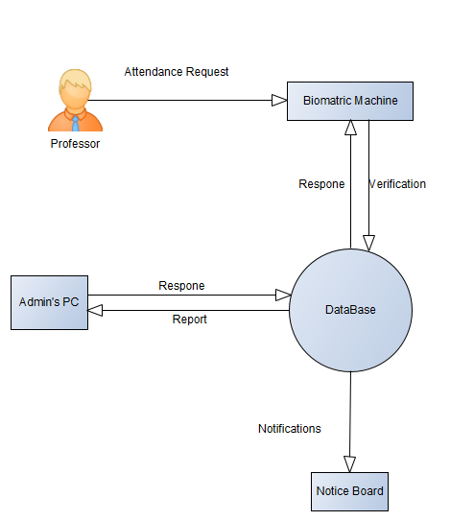

  - Hardware Interfaces
The hardware components included in projects are following
Admin’s PC
The admin is the main person who will manage this system. He will handle the database and generate reports of attendance and enter data, edit and delete details of professors.
Biometric Machine
The biometric machine will scan the fingerprint of the professor and will generate a request to verify the details of the professor from the database. On the verification of data from the database system will automatically assign a new id and add time in or out of the professor.
Notice Screen
Notice board screen fetches details of professors and room details to show reserved room data on screen and also show important Notices.

  - Software Interfaces
This project contains MySQL database and the operating system is Windows with a chrome browser the tools are VS code using angular.js and java. Libraries that are included are bootstrap 3.4.1 and Angular script 14.2.0.
Using a biometric machine professor will verify his fingerprint in this manner request for verification is generated by the biometric machine this data will be sent to the admin’s PC via HDMI cable admin’s PC will verify the thumbprint from the database.
On the other hand, for digital notice board admin will generate important notices this data will be shared to the notice screen wirelessly.

  - Communications Interfaces
We will establish the connection between the biometric machine and the admin’s PC via HDMI cable. This transmission will be a full duplex. Notice screen will be connected to the admin’s PC wirelessly. The transmission between the admin’s PC and the Notice screen will be simple as data will be only transferred from the admin’s PC.

Functional Requirements
This section should contain a textual description of the requirements related to the customer’s business. This should contain a list of all the business events related to the business process.

The functional requirements of the biometric attendance system and digital notice board are the following.
- Professor will be registered into the system.
- The system will maintain unique biometric information.
- Admin will manage attendance-related records.
- Only the admin can update or delete the registered professors.
- This System will be able to mark attendance by placing the finger on the fingerprint sensor.
- The system will manage the attendance records as per their fingerprint records.
- This system can record the time in and out of the professor.
- Only the admin will have access to the notice board.
- Important notices will only be generated by the admin.
- This system will also be able to display reserved room information on a digital notice board.

Non-functional Requirements

  - Performance Requirements
As project uses HDMI wire for communication between the biometric machine and the admin's system and also uses the Local Area Network (LAN) of the university for communication between the admin’s PC and notice board so it’s a secure and flexible pathway. It can also handle multiple requests from the biometric system.

  - Safety Requirements
As the system is secured by username and password so only the admin will have access to the system only he can access the database. So it is not easy for anyone to damage the credentials of a professor from the database. Another safety risk in this project is the safety of hardware components. So to prevent this type of risk we have to monitor hardware components through CCTV cameras of the department.

  - Security Requirements
To increase the integrity of the system only the admin has access to the system. Also, the requests from the biometric attendance machine can be delivered safely using wired communication between the machine and the admin’s PC. On the other hand, the transmission of information between the admin’s PC and to Notice board is secured by the screen-sharing process.

  - User Documentation
The delivery of this software includes a user manual that will guide users that how to interact with the hardware and software components of this system.

Assumptions and Dependencies
Assumptions for this system are
- In the future, if requirements change like system also have a feature to mark the attendance of Non-academic staff and students via a biometric machine
- If we add a module for salary based on attendance.
- Leave the management of staff.

Dependencies for the system are
- As biometric machine needs electricity to perform their functionality so our system is also dependent on electricity.

System Architecture
Admin is the main actor of this system he will add details of the professors and will show important notices on the digital notice board. Admin’s pc is connected to the database and also connected to the notice board so that he can show important notices on the screen.
When a professor generates a request for attendance using a Biometric Machine first machine will verify the professor's details from the database and then will mark attendance and also record the time-in and out of the professor with room detail.
On the other end, the student can get necessary details or read important notices on a digital notice board.
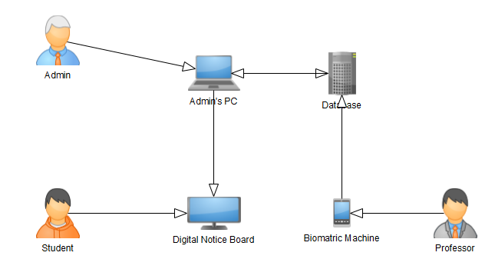

- Data Flow Diagram

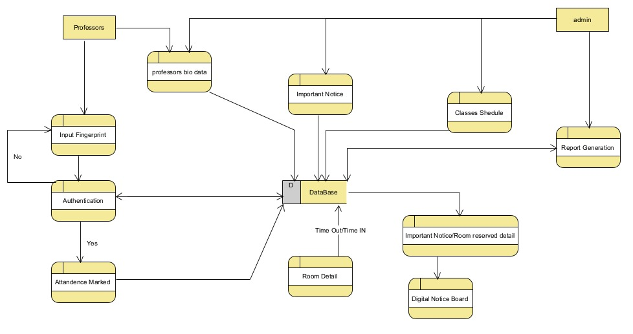
- Level 1 Diagram
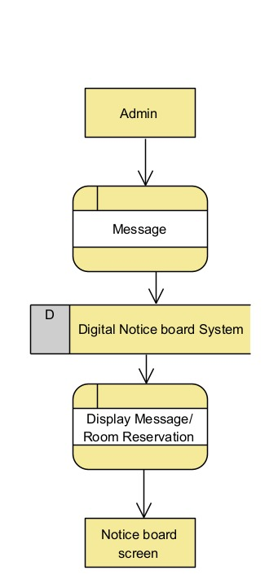
- Level 1 Diagram
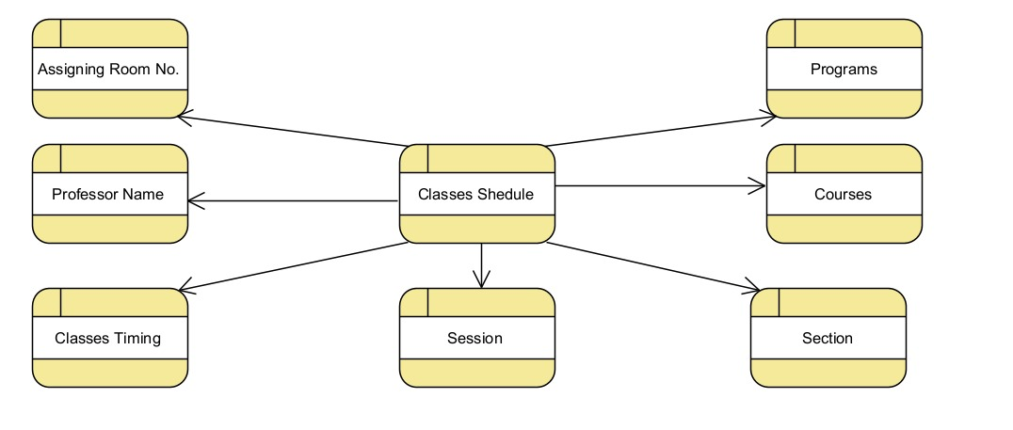
- Level 1 Diagram
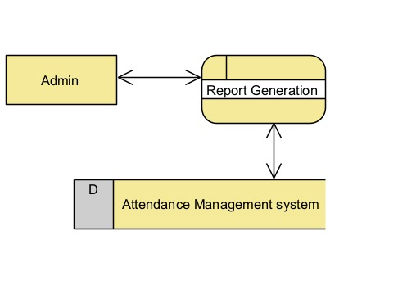
- Level 1 Diagram
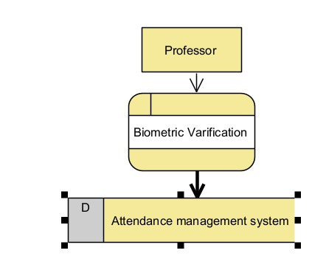
- Level 1 Diagram
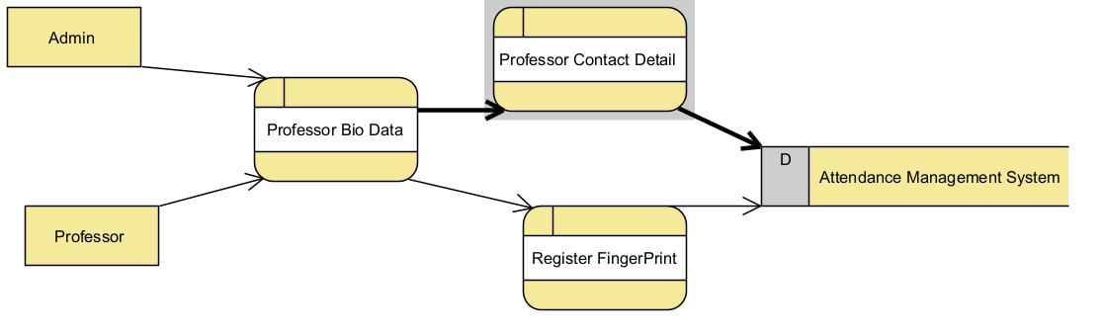

Use Cases

  - Use Case Diagrams
This section provides use case diagrams using UML convention.
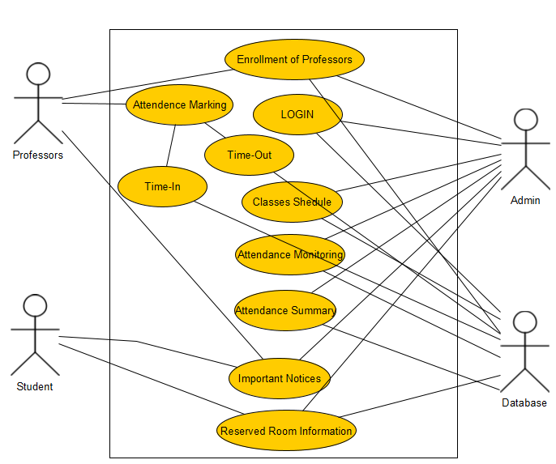

  - Use Case Description
Each Use Case has a description, which describes the functionality that will be built into the proposed system. The template for the Use Case description is given below:

1.1.0: LOGIN
Actors: Admin
Feature: Admin will get access to his account
Use case Id: |  | 1.1.0
Pre-condition: |  | As only the admin has access to the system so the authentication of the admin is necessary.
Scenarios
Step# | Action |  |  | Software Reaction
1. | Login Page |  |  | Admin will first interact with the login page of the system.
2. | Input username |  |  | Admin then enters the user name.
3. | Password Input |  |  | After the username admin will enter the password.
4. | Click on the LOGIN button |  |  | After that admin will click on the login button to verify the details
5. | Login Verification |  |  | The login page verifies the details that are given by the admin and then will respond according to the results.
2

Post Conditions
Step# | Description
1 | Admin will get access to the system.
Use Case Cross referenced |  |  | Thein, Moth Myint, and Tun CMNHM. "Students’ Attendance Management System Based On RFID And Fingerprint Reader." INTERNATIONAL JOURNAL OF SCIENTIFIC & TECHNOLOGY RESEARCH (2015): 30-38.
User Interface reference |  |  | 1.0.0

1.1.3: Prof. Registration
Actors: Admin
Professor
Feature: Admin will register Professor's details
Use case Id: |  | 1.1.3
Pre-condition: |  | For attendance, the admin will register the professor in the system.
Scenarios
Step# | Action |  |  | Software Reaction
1. | Admin will enter Professor’s data |  |  | In this section, the admin will enter the details of the professor in the admin registration form.
2. | Data will be saved in the database |  |  | All the data entered by the Admin will be saved in the database of the system
2

Post Conditions
Step# | Description
1. | After the registration process professor will be able to mark attendance via a biometric machine
Use Case Cross referenced |  |  | Thein, Moth Myint, and Tun CMNHM. "Students’ Attendance Management System Based On RFID And Fingerprint Reader." INTERNATIONAL JOURNAL OF SCIENTIFIC & TECHNOLOGY RESEARCH (2015): 30-38.
User Interface reference |  |  | 1.0.3

1.1.7: Urgent Message
Actors: Admin
Professor
Student
Feature: Important Notices will be shown on the screen which is sent by Admin
Use case Id: |  | 1.1.7
Pre-condition: |  | Only Admin has access to send notices to the notice board.
Scenarios
Step# | Action |  |  | Software Reaction
1. | Admin Write Message |  |  | In the first stage, Admin will first write the message on the urgent message page and then he will click on the display button.
2. | The message will be saved in the database |  |  | The message written by the admin will be first saved in the database of the system.
3. | Fetching Message |  |  | Message in the database will be fetched by the notice board page and will be shown by the display.
2

Post Conditions
Step# | Description
1. | Faculty members and Students can read crucial messages on the notice board.
Use Case Cross referenced |  |  | Thein, Moth Myint, and Tun CMNHM. "Students’ Attendance Management System Based On RFID And Fingerprint Reader." INTERNATIONAL JOURNAL OF SCIENTIFIC & TECHNOLOGY RESEARCH (2015): 30-38.
User Interface reference |  |  | 1.0.7

1.1.8: Room Reservation
Actors: Admin
Professor
Student
Feature: Reserved Room details will be shown on notice board screen
Use case Id: |  | 1.1.8
Pre-condition: |  | Reserved room details will show with the professor's name and class details like course, semester, etc.
Scenarios
Step# | Action |  |  | Software Reaction
1. | Fetching of room reservation details |  |  | The Notice board page will fetch data about rooms and display it on the notice board.
2

Post Conditions
Step# | Description
1. | Room reservation details will be shown on the screen.
Use Case Cross referenced |  |  | Thein, Moth Myint, and Tun CMNHM. "Students’ Attendance Management System Based On RFID And Fingerprint Reader." INTERNATIONAL JOURNAL OF SCIENTIFIC & TECHNOLOGY RESEARCH (2015): 30-38.
User Interface reference |  |  | 1.0.8

1.1.6: Time Table
Actors: Admin
Feature: Admin will set classes schedule
Use case Id: |  | 1.1.6
Pre-condition: |  | Admin will set the Classes Schedule with room details, course details, session, and section details.
Scenarios
Step# | Action |  |  | Software Reaction
1. | Scheduling Classes |  |  | Admin will schedule classes time and a lot of rooms etc. he will fill the fields of time table scheduling page.
2. | Data saved in the database |  |  | When the admin tries to save the data about the scheduling of classes it will be saved in the database of the system.
2

Post Conditions
Step# | Description
Use Case Cross referenced |  |  | Thein, Moth Myint, and Tun CMNHM. "Students’ Attendance Management System Based On RFID And Fingerprint Reader." INTERNATIONAL JOURNAL OF SCIENTIFIC & TECHNOLOGY RESEARCH (2015): 30-38.
User Interface reference |  |  | 1.0.6

1.1.10: Attendance Marking
Actors: Professor
Feature: professor will mark attendance via a biometric machine.
Use case Id: |  | 1.1.10
Pre-condition: |  | Professors will authenticate their fingerprints through a biometric machine outside the room to mark the arrival and departure time of professors.
Scenarios
Step# | Action |  |  | Software Reaction
1. | Biometric input |  |  | Professor will place a finger on the sensor of the machine and will try to verify the details.
2. | Verification |  |  | Impression data will be sent to the database for verification by the professor.
3. | Marking Time-In or Out |  |  | After the verification of the professor's details, attendance will be marked in the database of the system.
2

Alternate Scenarios:
1a: In case the biometric sensor doesn’t work an alternative scenario is to input the password given to the professor.

2a:

Post Conditions
Step# | Description
1. | Professor’s attendance will be marked.
Use Case Cross referenced |  |  | Thein, Moth Myint, and Tun CMNHM. "Students’ Attendance Management System Based On RFID And Fingerprint Reader." INTERNATIONAL JOURNAL OF SCIENTIFIC & TECHNOLOGY RESEARCH (2015): 30-38.
User Interface reference |  |  | List user interface(s) that are related to this use case. Use numbered list in case of more than one user interface element.

1.1.11: Attendance Monitoring
Actors: Admin
Feature: Admin will monitor the attendance of professors.
Use case Id: |  | 1.1.11
Pre-condition: |  | Admin will monitor the attendance of professors from the database and monitor the time in and out of professors
Scenarios
Step# | Action |  |  | Software Reaction
1. | Fetching attendance details |  |  | Admin can monitor attendance by viewing the details saved in the database.
Post Conditions
Step# | Description
 | Sequentially list conditions expected after the use case.
Use Case Cross referenced |  |  | Thein, Moth Myint, and Tun CMNHM. "Students’ Attendance Management System Based On RFID And Fingerprint Reader." INTERNATIONAL JOURNAL OF SCIENTIFIC & TECHNOLOGY RESEARCH (2015): 30-38.
User Interface reference |  |  | List user interface(s) that are related to this use case. Use numbered list in case of more than one user interface element.

1.1.12: Attendance Summary
Actors: Admin
Feature: Admin will generate Summary or report of attendance of professor when required
Use case Id: |  | 1.1.12
Pre-condition: |  | Summaries will be generated through the previous records of professors' attendance
Scenarios
Step# | Action |  |  | Software Reaction
1. | Attendance Summary |  |  | Summaries will be generated according to the previously saved data on the attendance of professors in the database. Summaries of attendance will be based on that saved data on the database.
2

Post Conditions
Step# | Description
 | Sequentially list conditions expected after the use case.
Use Case Cross referenced |  |  | Thein, Moth Myint, and Tun CMNHM. "Students’ Attendance Management System Based On RFID And Fingerprint Reader." INTERNATIONAL JOURNAL OF SCIENTIFIC & TECHNOLOGY RESEARCH (2015): 30-38.
User Interface reference |  |  | List user interface(s) that are related to this use case. Use numbered list in case of more than one user interface element.

Graphical User Interfaces
Give a detailed account of user interfaces included in this project.

LOGIN
Interface Id. |  | 1.0.0
Use case Reference |  | 1.1.0
Snapshot
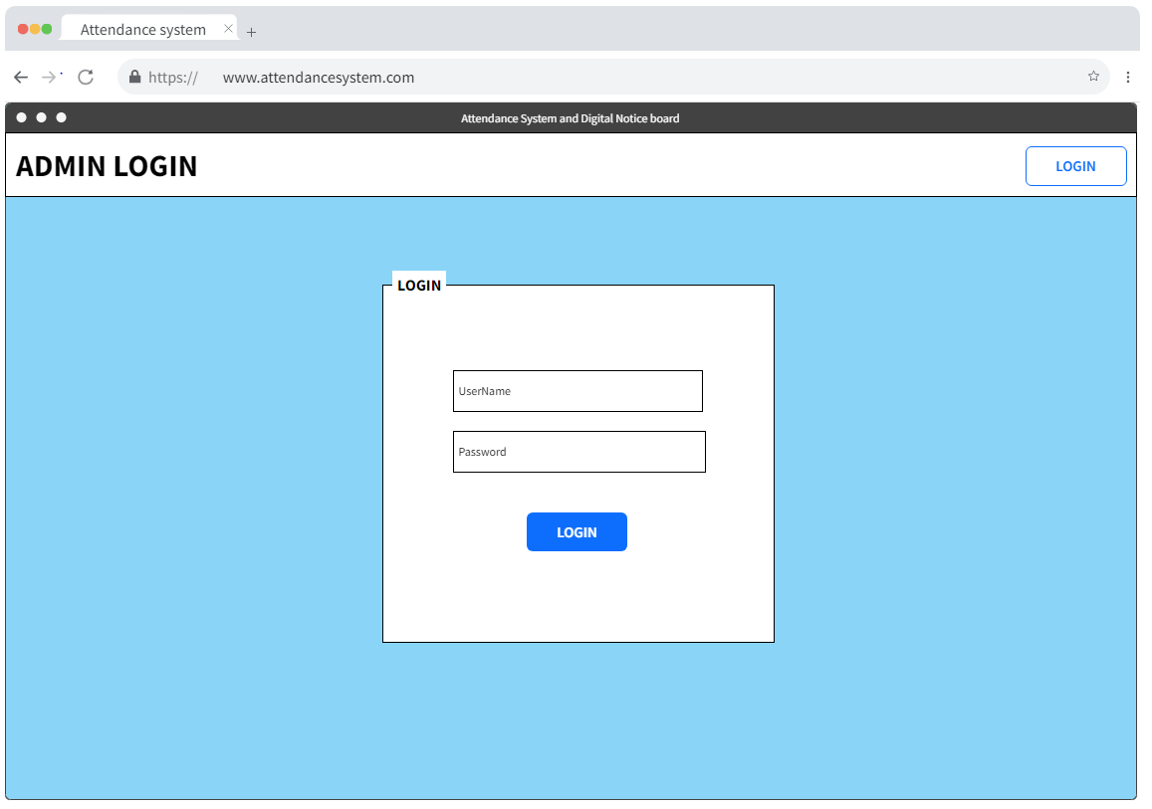
Data dictionary reference
Label | Data dictionary identifier
1. | 10.1: ADMIN

Attendance
Interface Id. |  | 1.0.1
Use case Reference |  | 1.1.1
Snapshot
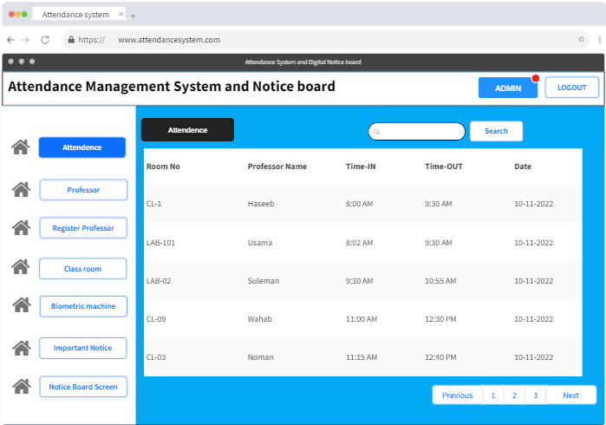

Data dictionary reference
Label | Data dictionary identifier
1. | 10.10: Attendance

Professor
Interface Id. |  | 1.0.2
Use case Reference |  | 1.1.2
Snapshot
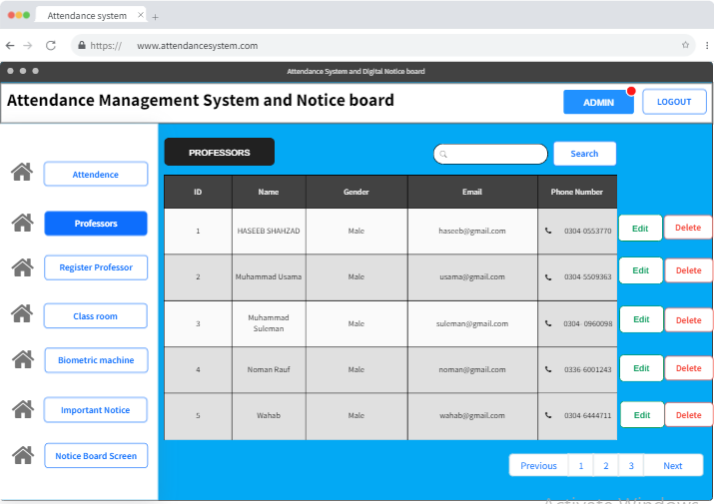
Data dictionary reference
Label | Data dictionary identifier
1. | 10.2: Professor

Register Professor
Interface Id. |  | 1.0.3
Use case Reference |  | 1.1.3
Snapshot
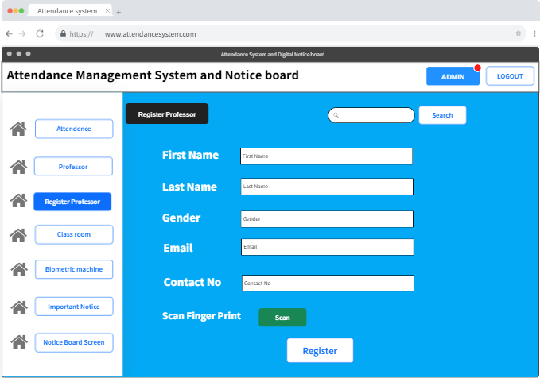
Data dictionary reference
Label | Data dictionary identifier
1. | 10.2: Professor

Class Room
Interface Id. |  | 1.0.4
Use case Reference |  | 1.1.4
Snapshot
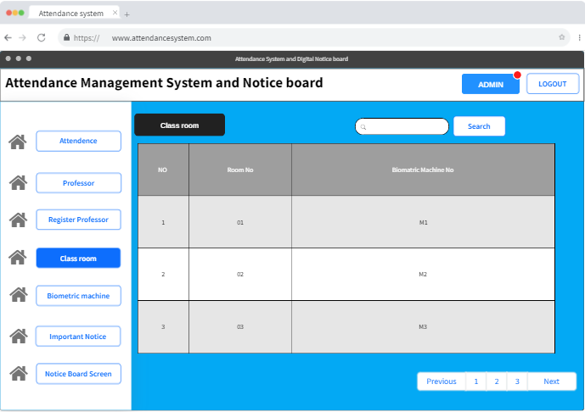
Data dictionary reference
Label | Data dictionary identifier
1. | 10.5: Room

Biometric Machine
Interface Id. |  | 1.0.5
Use case Reference |  | 1.1.5
Snapshot
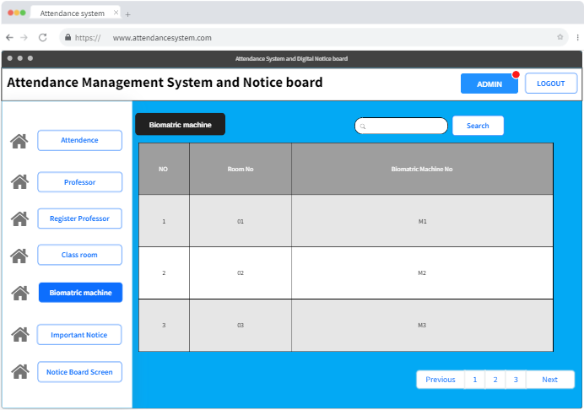
Data dictionary reference
Label | Data dictionary identifier
1. | 10.3: Biometric Machine

Classes Schedule
Interface Id. |  | 1.0.6
Use case Reference |  | 1.1.6
Snapshot
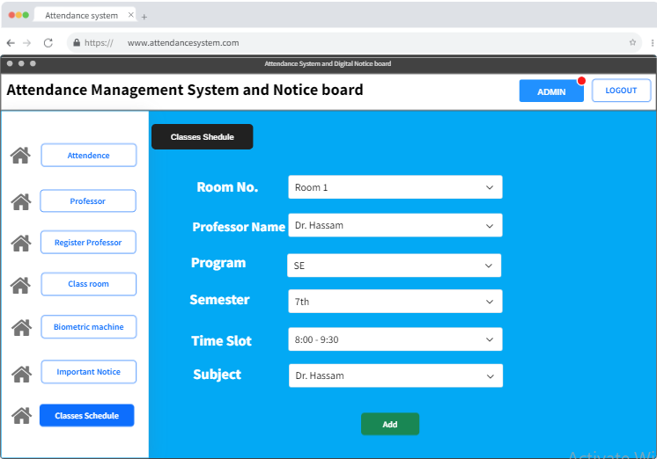
Data dictionary reference
Label | Data dictionary identifier
1. | 10.9: Timetable

Important Notice
Interface Id. |  | 1.0.7
Use case Reference |  | 1.1.7
Snapshot
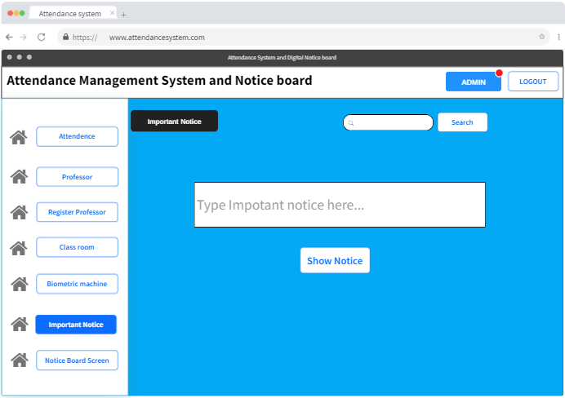
Data dictionary reference
Label | Data dictionary identifier
1. | 10.4: Notice Board

Notice Board
Interface Id. |  | 1.0.8
Use case Reference |  | 1.1.8
Snapshot
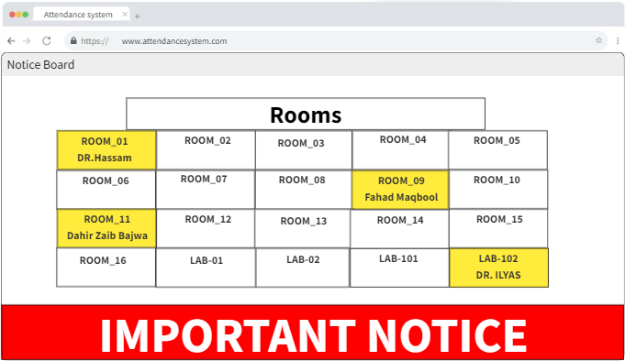
Data dictionary reference
Label | Data dictionary identifier
1. | 10.4: Notice Board

High-Level Design

  - ER Diagram
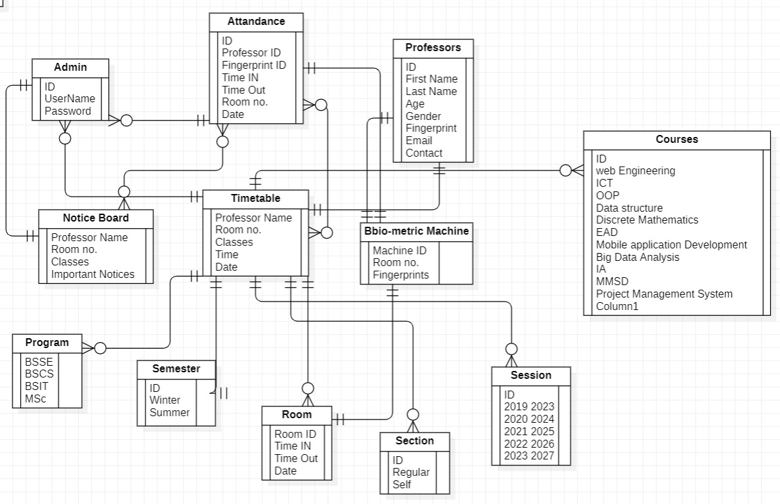
  - Data Dictionary
The convention recommended for writing the data dictionary is as follows.

    - Data 1
10.1: ADMIN
Name | Usama
Alias | Admin (Team Member)
Where-used/how-used | Admin can manage details of Professors, Room, Machine details, Generate Details, and can Display important notices.
Content description | Admin has an ID, Username, and Password.
Supplementary information | If the admin wants access to data then he must have to give the correct username and password.

    - Data 2
10.2: Professor
Name | Haseeb
Alias | Teacher (Team Leader)
Where-used/how-used | Professor will generate a request for attendance through a biometric machine
Content description | All required details of the professor like Name, contact, fingerprint expression, and email.
Supplementary information | Professor can only use his thumb or registered finger on the biometric machine for attendance.

    - Data 3
10.3: Biometric Machine
Name | 01
Alias | machine
Where-used/how-used | It will be used outside classrooms so that it will scan the thumb impression of the professor and will record time in and out of the professor and mark attendance.
Content description | Data about the professor and room details are included in it.
Supplementary information | The machine only matches fingerprints for attendance.

    - Data 4
10.4: Notice Board
Name | Notice Board
Alias | Display
Where-used/how-used | Notice board will be displayed in the department and will accept the request to display notices and reserved room details from the admin’s PC through screen sharing method.
Content description | Detail of professor, room no, classes, and important notices are part of the display.
Supplementary information | All details and notices can be displayed only from the admin’s PC

    - Data 5
10.5: Room
Name | CL-01
Alias | Room
Where-used/how-used | Room details are used to generate details about reserved rooms for digital notice boards and also maintain the data of biometric machines outside the room.
Content description | Rooms table include Time in and Time out detail with the date
Supplementary information | Other information about data types, preset values, restrictions or limitations, etc.

    - Data 6
10.6: Section
Name | C-RS
Alias | Section
Where-used/how-used | Section details are used to generate details for the digital notice board and also maintain the data of the biometric machine with professor attendance.
Content description | The section includes detail of classes in the same semester
Supplementary information | Other information about data types, preset values, restrictions or limitations, etc.
    - Data 7
10.7: Semester
Name | C-1
Alias | Semester
Where-used/how-used | Room details are used to generate details about reserved rooms for digital notice boards and also maintain the data of biometric machines outside the room.
Content description | The semester table includes all the present semesters of that department.
Supplementary information | Other information about data types, preset values, restrictions or limitations, etc.
    - Data 8
10.8: Program
Name | P-1
Alias | Program
Where-used/how-used | Program details are used to generate details about reserved rooms to display on digital notice boards and also maintain the data of the professor.
Content description | The program includes all the programs of that department.
Supplementary information | Other information about data types, preset values, restrictions or limitations, etc.

    - Data 9
10.9: Timetable
Name | T-W-07-11-2022
Alias | week
Where-used/how-used | A timetable is used for checking the schedule of classes and professors.
Content description | It contains classes schedule according to the time and with the name of the professors.
Supplementary information | The timetable will be added to the database for checking the class’s schedule.

    - Data 10
10.10: Attendance
Name | DB-01
Alias | Attendance
Where-used/how-used | The attendance server is used to maintain the records and data of professors.
Content description | The database has details of professor id, time detail, according to date
Supplementary information | Data is only accessible to the admin and all detail is a useful creating summary

    - Data 11
10.11: Courses
Name | C-01
Alias | Course
Where-used/how-used | This table holds all the courses which are offered in the department to manage the schedule of classes
Content description | It contains the course name that names will be assigned to classes
Supplementary information | StudentsStudentst details about scheduled classes of each course through digital notice.

    - Data 12
10.12: Section
Name | SC-01
Alias | Section
Where-used/how-used | Section details are also required to maintain the details of class schedules.
Content description | The section contains the details about regular and self.
Supplementary information | Students can get details about scheduled classes of each course through digital notice.

Requirements Traceability Matrix

Sr. # | Feature | Use case ID | UI ID | Priority | Build Number
 | Admin Login | 1.1.0 | 1.0.0 | 1 | 1
 | Enrollment of Professor | 1.1.3 | 1.0.3 | 2 | 2
 | Classes Schedule |  |  | 3 | 3
 | Attendance Marking | 1.1.1 | 1.0.1 | 4 | 4
 | Professor’s Detail | 1.1.2 | 1.0.2 | 5 | 5
 | Class Room Details | 1.1.4 | 1.0.4 | 6 | 6
 | Biometric Machine | 1.1.5 | 1.0.5 | 7 | 7
 | Important Notice | 1.1.6 | 1.0.6 | 8 | 8
 | Reserved Room Details | 1.1.7 | 1.0.7 | 9 | 9

Risk Analysis
The risks of the Biometric attendance system are following.
- Injection flaws:
When no reliable data is supplied to a program as part of a command, injection problems like SQL, NoSQL, and OS injection happen. As a result, malicious data from attackers can deceive the application into carrying out unexpected orders, like proving access to data without the necessary authorization.
- Broken Authentication:
Any security flaw that interferes with an application's log-in process is known as broken authentication. Attackers are free to compromise user passwords and session tokens when authentication is compromised, or they can take advantage of implementation defects. By using automated methods to break user account passwords, brute force attacks may become possible on the system.
- Sensitive data exposure:
On web applications and APIs, data, like customer credit card information and session tokens, is frequently left accessible, making it possible for attackers to steal it and commit crimes like identity theft. It is vital to use encryption and to make sure that there are no application logic errors that could allow unauthorized access to prevent the exposure of this and other sensitive data.
- Broken Access Control:
The process through which an application limits access to data or functionality is referred to as access management. When limitations on what users may do are not effectively enforced, such as when a person with low privileges can access data that only a highly privileged user should be able to access, broken access control vulnerabilities occur.
- Security Misconfiguration:
A relatively typical sort of web application vulnerability is security misconfiguration. It is used to indicate open storage, inadequate configuration, and insecure default settings. Even a tiny setup error, such as showing excessive information in error messages, might cause issues.

Cost Estimation Sheet

 | Software development cost | 10,00,000 rupees only
 | Packaged software | 50,000 rupees only
 | Hardware | 1,50,000 rupees only
 | Network | 50,000 rupees only
 | Client | 20,000 rupees only
 | Misc. | 2,50,000 rupees only
 |  | Total cost =15,20,000 only

References

- Ujan, Imran Anwar, and Imdad Ali Ismaili. "Biometric attendance system." The 2011 IEEE/ICME International Conference on Complex Medical Engineering. IEEE, 2011.
- Ganesh, E. N. "Implementation of digital notice board using raspberry pi and iot."
Oriental journal of computer science and technology 12.1 (2019): 14-20.
- Rahman, Sifatnur, Mahabur Rahman, and Md Mijanur Rahman. "Automated student attendance system using fingerprint recognition." Edelweiss applied science and technology 1.2 (2018): 90-94.
- Said, MA Meor, et al. "Biometric attendance." 2014 International Symposium on Technology Management and Emerging Technologies. IEEE, 2014.
- Jain, Tripti, et al. "IoT based biometric attendance system." International Journal of Electrical Engineering & Technology 11.2 (2020).
- Chennattu, Sebastian, et al. "Portable biometric attendance system using IoT." 2019 4th International Conference on Information Systems and Computer Networks (ISCON). IEEE, 2019.

